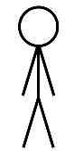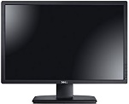Project Title: HelloWorld  
Goal: Design a game that meshing learning programming with an enjoyable gaming experience.  
  
D0: High Level Design Diagrams – shows basic input and output along with high level game design plans  
  
  
  
  
  
  
  
  
  
  
  
  
  
  
  
  
  
  
  
  
  
  
D1/D2: Lower Level Design Diagrams – shows more specifics on game design

Notes will include coding lessons/tips

Can review these notes in game or in **Title Screen** via **Review Lessons**

Objects respond accordingly based on user code

Collect tutorial notes through game as they progress

**User**

Interacts with objects in game via coding statements

**User**

Quit

Review Lessons

Settings

Start Game

Title Screen

Launch Game

**User**

**User**

**Output Monitor**

User actions reflected on monitor during gameplay

Input interpreted by Game Engine and Scripts

Mouse & Keyboard Input